**Identifiers in Python**

An Identifier is just a name used to identify a variable, function, class, module or other object**.**

Rules for writing identifiers:

1. Use only alphanumeric characters and underscores.
2. Never start with a number
3. User underscores to separate two words.
4. Pre-defined Keywords cannot be identifiers.  
   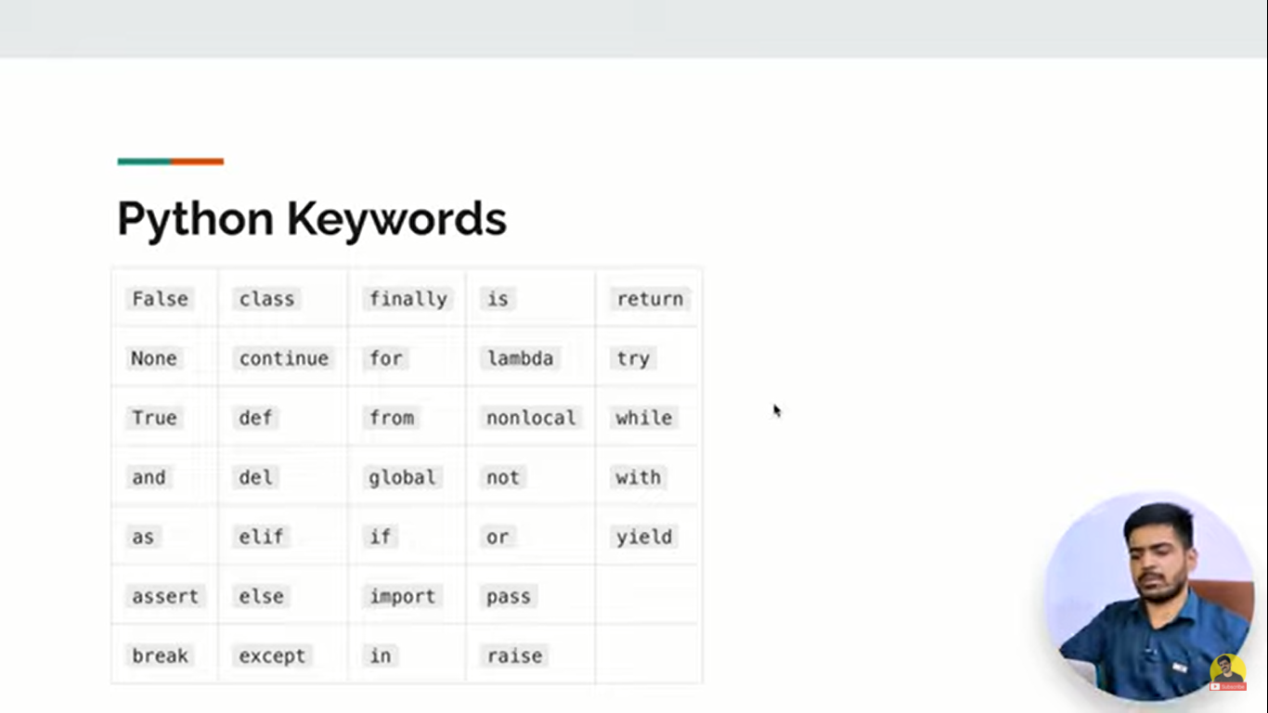  
    ***Pre-defined or Reserved Keywords in Python***

**Example of Identifier** in Python:  
**age** = 21  
**name** = “Chandan”